Workshop 1 — Signup Form (Student Handout)
Goal: Complete the remaining 20% of the signup form project to make a working, styled signup page.

Learning objectives
- Practice HTML structure and semantic elements.
- Practice CSS layout (flexbox), selectors, and basic form styling.
- Read and follow TODO comments in a starter project.
- Debug and test a simple form UI in the browser.

Files provided to you (starter)
- index.html — 80% completed HTML file (contains TODO comments where you must add code)
- style.css — 80% completed CSS file (contains TODO comments where you must add styles)
- pic1.jpg — background image placeholder
You will be given the starter files. Open them in your code editor (VS Code / Notepad++ / etc.) and open index.html in a browser to preview.

Tasks (what you must complete)
Each TODO in the starter files represents a small task. Complete all of the TODOs below.

1. Left column — content
- Add the missing two list items to the feature list:
  - Water Sports & Activities
  - Airport Transfers
- Add the price block (below the list):
- <p class="price">$1,299 <span class="old">$1,899</span></p>

2. Form fields (right column)
- Create the Gender + Date of Birth row (same structure as other .row blocks). The gender field should be a <select> with Select Gender, Male, Female options. Date of birth should be <input type="date">.
- Add the Phone Number field in its own row (single column if you prefer). Use <input type="text"> and a placeholder such as +1 (555) 123-4567.
- Add the Password field with <input type="password"> and a small hint below using <small>Must be at least 8 characters long</small>.

3. CSS styling
Add the missing CSS rules marked as TODO:
- Left section background image — set background-image: url("pic1.jpg"); background-size: cover; background-position: center;.
- Style the feature list bullets (.left ul li) so they show a white checkmark before each item (or use an icon/emoji). The starter used :before { content: "✔" }.
- Complete layout rules for .row and .col so the form fields align in two columns where applicable.
- Style labels and inputs (font-size, margin). Inputs should have padding, border and border-radius.
- Style the .price and .old classes (bold price and smaller struck-through old price).

Given Output

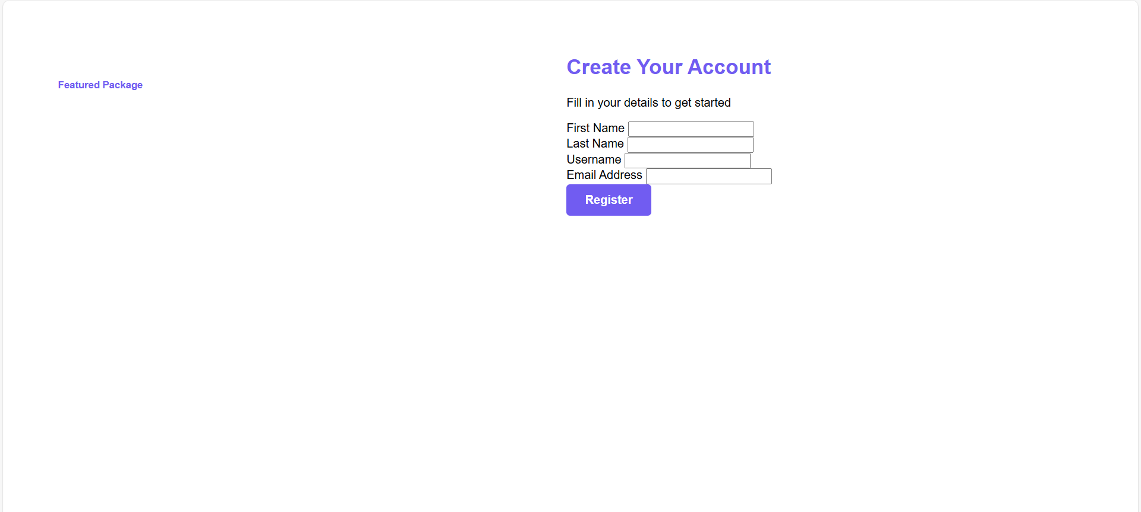
Expected Output

